Docker Compose Practical Questions

Question 1: Deploy Apache HTTP Server using Docker Compose
Create a docker-compose.yml file to run an Apache web server with port mapping and volume mount.

docker-compose.yml
version: "3"
services:
web:
image: httpd
container_name: apache_server
ports:
- "8081:80"
volumes:
- ./website:/usr/local/apache2/htdocs

Steps to Run
1. Create project folder:
mkdir apache-compose
cd apache-compose
2. Create website folder:
mkdir website
3. Create index file:
notepad website/index.html
4. Create docker-compose.yml and paste the code.
5. Start container:
docker compose up -d
6. Verify running container:
docker ps
7. Open browser:
http://localhost:8081
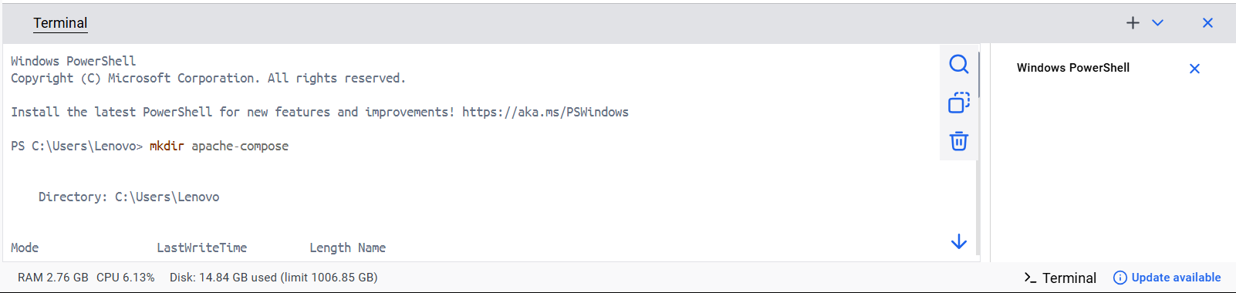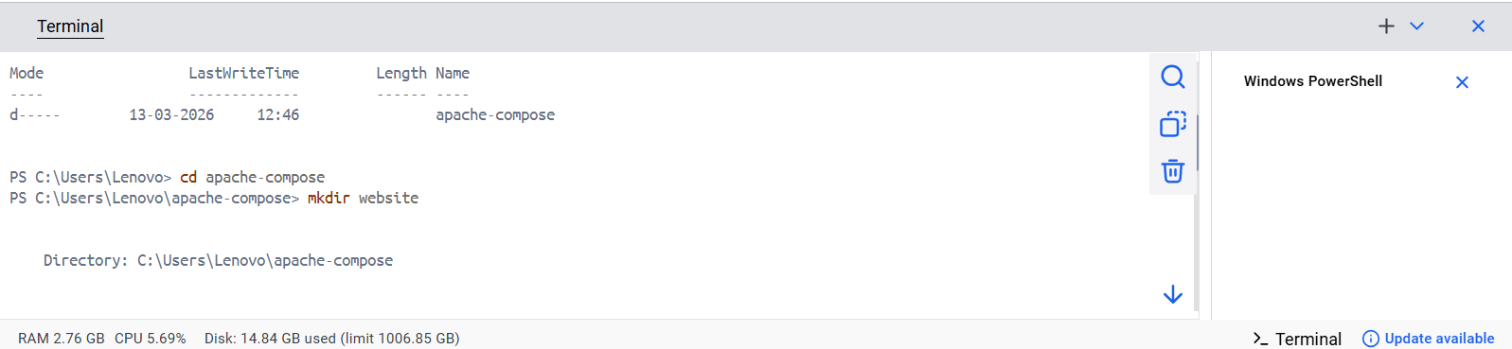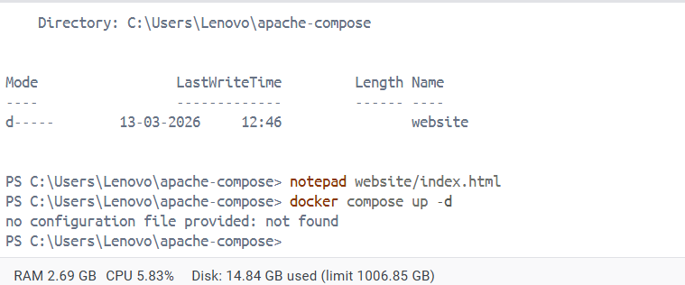

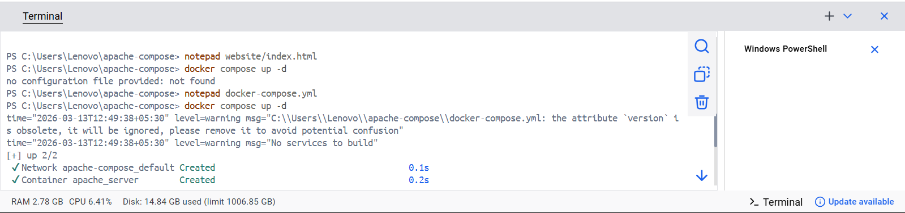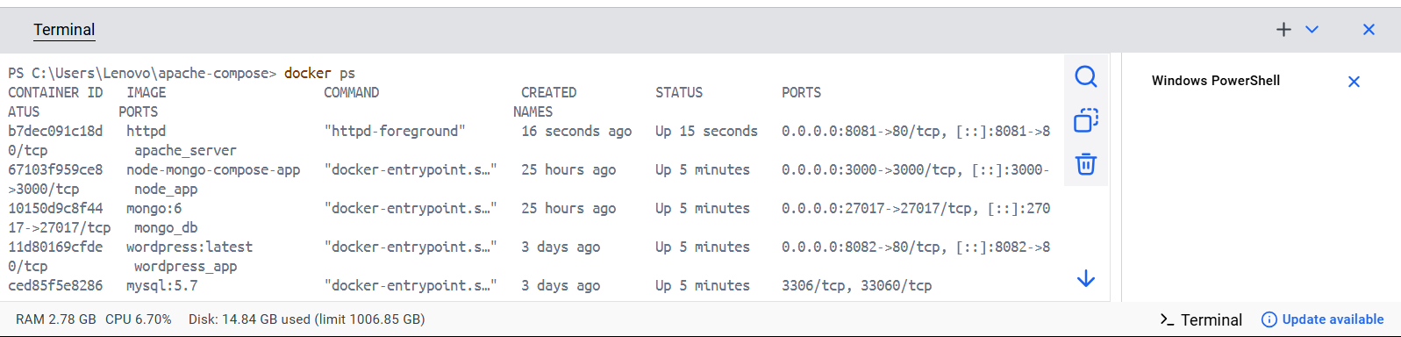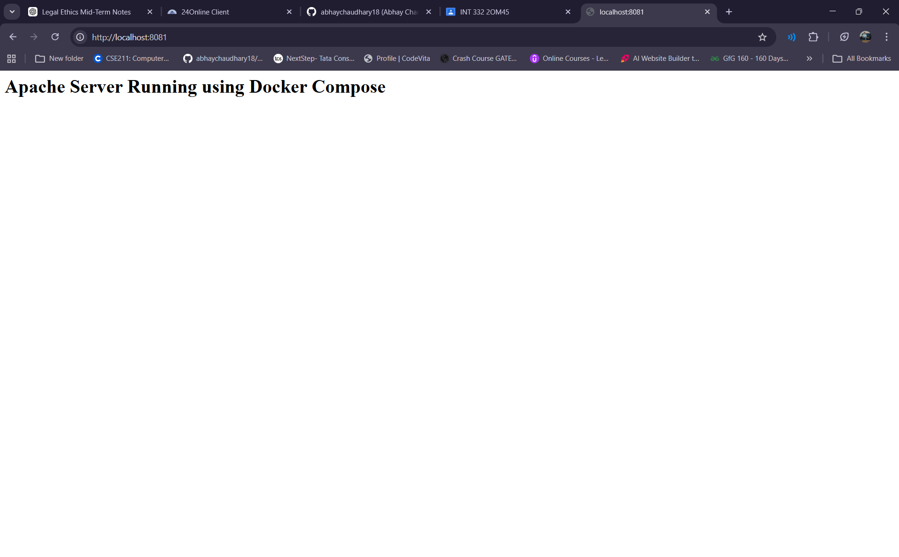

Question 2: Deploy Nginx and Redis using Docker Compose
Create a docker-compose.yml file with two services running on a custom network.

docker-compose.yml
version: "3"
services:
service1:
image: nginx
container_name: nginx_server
ports:
- "8085:80"
networks:
- appnetwork
service2:
image: redis
networks:
- appnetwork
networks:
appnetwork:

Steps to Run
1. Create folder:
mkdir nginx-redis-compose
cd nginx-redis-compose
2. Create docker-compose.yml and paste the code.
3. Start containers:
docker compose up -d
4. Check containers:
docker ps
5. Test nginx server:
http://localhost:8085
